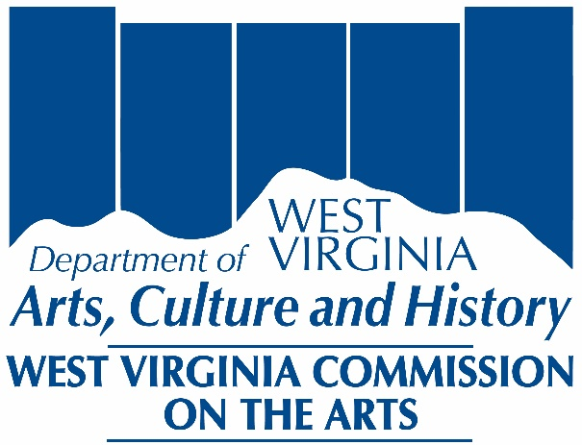

Mini Grant
Final Report

Included in the packet:

Instructions for preparation
Final Report forms Parts I – II

Part I
Final Report Cover Sheet

Part II
Final Report Project Evaluation & Summary

All publications and application forms are available in alternate formats. Contact Accessibility Coordinator at 304/558-0240 Ext. 725 (voice) 304/558-3562 (TDD)
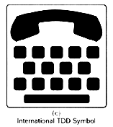

Mini Grant
Final Report Instructions

All sections of the Final Report must be typewritten. Do not staple or bind materials. You may use paperclips to separate projects. Final Reports must be submitted with the original signature. Final Report forms are available at http://www.wvculture.org on the grant forms and instructions page.

PART I: FINAL REPORT COVER SHEET

- One copy of this form must accompany all Mini Grant final reports.
- Enter applicant organization’s name and address. This form requires the organization’s legal name as recognized by the IRS and the WV Secretary of State.
- Enter your organizations Federal Employee Identification Number.
- For Contact Person, enter the person to be called with questions.
- Please list daytime phone numbers and e-mail/website, if applicable.
- Final Report Budget Summary:
  - Enter Grant Amount Awarded.
  - Grant Amount Spent is the actual amount of awarded grant funds expended to complete the project.
  - Total Applicant Matching Cash Funds is the actual funds your organization put toward the successful completion of the funded project, including organization cash, income from the project, and other support. This is the amount from line C on the final report budget summary.
  - Total Project Expenses is the sum of lines B & C.
- Read the certification information carefully, and sign and date. Be sure to circle the accounting method used by your organization. The final report cover sheet must be notarized in the space provided by all applicants except governmental entities.

Part II: FINAL REPORT PROJECT EVALUATION & SUMMARY

- One copy of this form must accompany all Mini Grant final reports. This form represents a
summary of the project with actual expenses and income.
- Enter applicant name.
- Enter the total number of individuals benefiting.
- Enter the total number of youths served and total number of artists included.
- Indicate if the project was open to the public and the cost of tickets (if applicable).
- Choose checkbox A – E to indicate the one item that best describes the PRIMARY strategic outcome associated with this project award.
EVALUATION:
- Please answer all questions in the space provided. Additional comments of up to one page may be
included.
Part I
Do not write in this space
Date received:
Application #:
PRN:
Final Report Cover Sheet

Applicant Legal Name: (organization):

Mailing Address: City:
State: County: Zip Code:
FEIN #: Contact Person:
Telephone (daytime): Website:
E-mail address:

Final Report Budget Summary:
A) Total Grant Amount Awarded: $
B) Total Grant Amount Spent: $
C) Total Applicant Matching Cash Funds: $
D) Total Project Expenses: $

Certification:
I certify that I have reviewed the grant receipts and expenditures submitted within this final report and, to the best of my knowledge and belief, said report represents all financial activities related to the receipt, use and expenditure of funds granted by the West Virginia Commission on the Arts/West Virginia Division of Culture and History, and that the expenditures reported were for the purposes intended and in compliance with applicable laws, regulations and terms and conditions of the grant documents. The report of grant receipts and expenditures is presented on the ACCURAL/CASH (circle one – required by West Virginia State Code) basis of accounting and is supported by our financial records and related documentation.

Name: Title:

Signature: Date:

Notary required for all applicants except governmental entities.
STATE OF WEST VIRGINIA
COUNTY OF _________________________________________________
I, ___________________________________, a notary public in and for the said state, do hereby certify that __________________________________, whose name is signed to the writing above, has this day acknowledged the same before me.
Given under my hand this _____ day of _______________, 20___
My commission expires__________________________________
_____________________________________________________
Notary Public
Part II
Do not write in this space
Application #
PRN:
Project Evaluation & Summary

Please complete this form as a summary of all funded projects.

Applicant Legal Name: (organization):

Actual # of individuals benefiting: Actual # Artists participating:
Actual # youth benefiting:
Open to the Public? Cost of tickets: Adults $ Students $

NEA Primary Strategic Outcome:
- Choose checkbox A – E to indicate the one item that best describes the PRIMARY strategic outcome associated with this project award.
A. Creation: The Portfolio of American Art is Expanded
B. Engagement: Americans Throughout the Nation Experience Art
C. Learning: Americans of All Ages Acquire Knowledge or Skills in the Arts
D. Livability: American Communities Are Strengthened Through the Arts
E. Understanding: Public Knowledge and Understanding about the Contributions of the Arts Are Enhanced
EVALUATION
Please answer each of the following questions in the space provided.

- Artist presented:
Date: Location:
- Amount of applicant cash match: $
- Source of cash match (example: school fund, PTO, admission):
- Did the artist fulfill his/her responsibilities in a professional manner?
Explain:

For the next three questions, please circle the appropriate response:
- The quality of the artist’s work was: Excellent Good Fair Poor
- Student/audience interest in the project was: Excellent Good Fair Poor
- The artist’s rapport with audience was: Excellent Good Fair Poor

- Did the project affect your school’s/organization’s capacity to have similar future projects?
Explain:

- What was the strongest component of this project? Why?

- What was the weakest component of this project? Why?

Additional comments:
If needed, one additional page may be added for comments.

